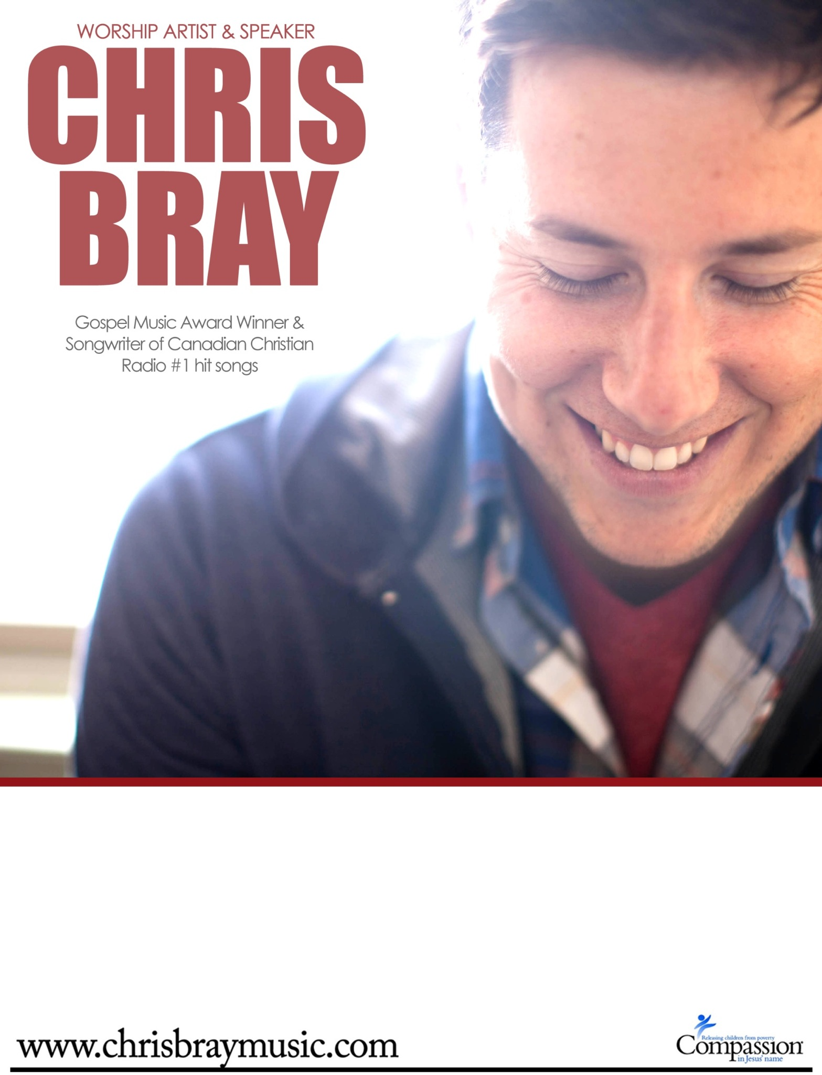

NIGHT OF WORSHIP
Saturday, March 24th @ 7pm
West Oro Baptist Church
(1827 Line 4 North, Edgar, ON))
FREE ADMISSION – Love offering collected.

